1

Overzicht van enkele oude vroeg Middeleeuwse documenten van naamdragers Moll (AD 759 – 1500)

Het alleroudste document van een naamdrager Moll handelt over **Aethelwald Moll en Aethelred Moll,** Saksische heersers in Northumbria uit de tijd van Karel de Grote.

England before the Norman (Viking,Wiking, Danish) conquest. Northumbria is divided into two parts: BERNICIA (north-) and DEIRA (south-) and they were joined together in 617. Under the reign of the Saxon **King Aethelwald Moll** (Aethelwald = "Adelwoud or Ewout" a cruel tyrant), and King of the Angelsaxons over the two parts of Northumbria , the Vikings invade Brittain for the first time. There are some indications that the Angel-Saxon Kings are related to the Merovingers,[Charles the Great, Karel de Grote: Charlemagne]. In a letter (± 785 AD) Charlemagne warns Aethelred Moll.

In the battle of Cadwinskip (759 AD) Aethelwald Moll defeated the Duke Oswin. In 765 Aethelwald Moll lost the battle of Winchenhal and then Ahlred, son of Canwin became the King. In 774, a son of Aethelwald, named Aethelred Moll, succeeded Ahlred. However, in 779 he was defeated and took his way to the King of the Picts, Talorgen (778-782) son of Drust . In 790 Aethelred returned. From that moment a periode of suppression, violence murder and manslaugther started.The devastation of the Christian British Isles by the pagan Norse and Danes began in 795AD with the plunder of Lindisfarne. During that time, the Vikings already were landed but they were defeated first by Aethelred Moll. However, due to local troubles, **Aethelred Moll was murdered 796** (see below) by his own men (under the command of Cardulf).

In 797 the murder on Aethelwald was revenged by Ealdorman "Thorthmund".

Sources can be found in a historical letter of Flaccus Albinus Alcuinus (Alcuin, York 735 - Tours 804), Abott of Canterbury, friend and advisor of Charles the Great:

Epistel 29, opera, pg 1537, (785 AD): A warning to Aethelred Moll I (" The usurpator ") from Charles the Great :

"De antiqua amitica - de fidei veritate - de pacis concordia - quam habere debitis inter vos (= Aethelred Moll) , quia amicitia quae deseri potest, NUNQUAM VERE FUIT" !

LIST of SOME ANGEL-SAXON KINGS of Northumbria and Britain.

Some of them are supposed to be related to an angel-saxon

"royal" family occasionally (sur)-named Moll. Those Moll´s ruled as

Saxon tyrants in Northumbria. Manslaughter was practised almost daily

Aethelferth - 593 - 617 -son of Aethelric,

Edwin - 617 - 633 (632?) -son of Aelle, he joined Deira and Bernicia :

Northumbria

Osric - 633 - 634 - (Edwin's cousin)

Oswald - 634 - 642 - King of Northumbria ,a son of Aethelfrith. It is assumed that he, Oswald, is an ancestor of Aelthelwald Moll (see below)

A half-brother of Oswald was Oswin, King of Deira: < St. Oswin, King of D King of Deira Born: AD Died: 20th August AD 651 St. Oswin grew up turmoil of early 7th century Northumbria. In AD 633, his father, Os secure the crown of Deira (modern Yorkshire) after the death of his Northumbria, at the Battle of Hatfield Chase. Bernicia was taken by but, within a year, both men had been massacred by their enemy, t and Mercians who were sweeping across the Country. The young O Wessex. While Oswin grew into a burly young man, Eanfrith's halfaccepted by both Bernicia and Deira as King of a united Northumbri their south-western invaders. He married the daughter of the King but there is no evidence of his making trouble for Oswin. Seven yea Oswald was dead. His brother, Oswiu, became King of Bernicia, but Deirans who recalled Oswin in AD 644. He may have made his peac

Mercians at this time and used their armies to assert his rights in t

When Edwin, King of Northumbria, died in 632, Eanfrith succeeded to

Bernica and Osric to eira. They each only reigned a year before Oswald,

Eanfrith's brother, took the whole of Northumbria under his crown. In 641, he was slain by King Penda of Mercia, and was succeeded in Bernica by his brother Oswui and in Deira by Oswine (who follows).Oswine, king of Deira and Saint ,20 August 651 killed on Oswiu's orders (who follows)

Oswiu- 642 (or 641) - 670 - brother of Oswald

- Under his reign Saint Willibrord was born in Northumberland. Saint Willibrord (c.657 - c.738) was an English missionary, known as the Apostle to the Frisians in modern Netherlands.

Ecgfrith 670 - 685 - son of Oswiu

Aldfrith - 685 - 705 - son of Oswiu and an Irish Princess.

Osred - 705 - 716 - son of Aldfrith

Coenred 716 - 718

Osric - 718-29 - son of Aldfrith

Ceolwulf - 729 -37

Aldfrith - 685 - 705 - son of Oswiu and an Irish Princess.

Osred - 705 - 716 - son of Aldfrith

Coenred 716 - 718

Osric - 718-29 - son of Aldfrith

Ceolwulf - 729 -37

Eadbriht (Moll ?) - 738-58 also spelt Eadbeorht (Egbert).

758-759 Oswulf - son of Eadbriht and possibly murdered by his brother Aethelwald Moll (who follows),a distant relative of Oswin of Deira(died: 20th August AD 651).

Aethelwald Moll I -759-65 - The Deiran patrician, (rather tyrant)

Aethelwald Moll, who probably conspired in the regicide (= murder of Kings), seizes the throne and dynastic stife ! Sources disagree on when he became king. He is supposed to be a descendant of Oswald, King of Northumbria / Deira.

761 - King Aethelwald Moll I of Northumbria, the tyrant, faces a rebellion under a rival claimant to the throne named Oswin.

The latter is defeated after the three day Battle of Eildon (Eldunum near Mailros). A Bernician revolt lead by throne claimant Prince Oswin was crushed and Oswin killed by false claimant Aethelwald Moll. In this year the Bernician leader Oswin was murdered by the Deiran Aethelwald Moll of Catterick at a place called Edwinscliffe on the borderland between the BERNICIA and NORTHUMBRIA (County Durham) . The duration of the battle suggest it had something of the character of a siege, and this in turn that a well-defended strong-hold was involved, possibly the fort on Eildon Hill North. Note: Some (Irish) sources indicate: On 761 (6 Aug) AEdwiresclif Moll, King of N'bria beat Oswine, King of Deira.

761: **King Aethelwald Moll (or Aethelwold ) of Northumbria** marries his Queen, Aethelthrith, at Catterick. Aethelwald Moll KING OF NORTHUMBRIA: Died ABT 765

765-74 -Alhred, his name is also written as Ealhred, or Elchred, (in English = Earle)

1. - Unrest in the Northumbrian Church appears to lead to the expulsion of King Elchred who is driven from York. He sails from Bamburgh into exile amongst the Picts. He is replaced by Aethelred Moll

I, the eleven year old son of the late King Aethelwald I Moll of Northumbria.

774-778 Aethelred Moll = Ealhred (Ethelred, Alcred, Aedelred), son of

Aethelwald Moll I

778- 89 Aelfwold I - - son of Osulf

779 - Offa, King of Mercia, becomes "King of All England". Offa defeats King Cynewulf of Wessex at the Battle of Bensington and seizes control of Berkshire, and probably London as well.

He is succeeded by his son, Aethelbert. King Aethelred I of Northumbria is driven from the kingdom by Prince Aelfwald, son of the late King Oswulf who takes the throne as Aelfwald I.

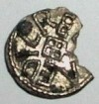

Silver coin of King Aethelred I Moll (read Aedilred)

789-90 -Osred II, son of Alhred

**790-796, Aethelred Moll I** (second reign) - son of Aethelwald Moll of Northumbria.

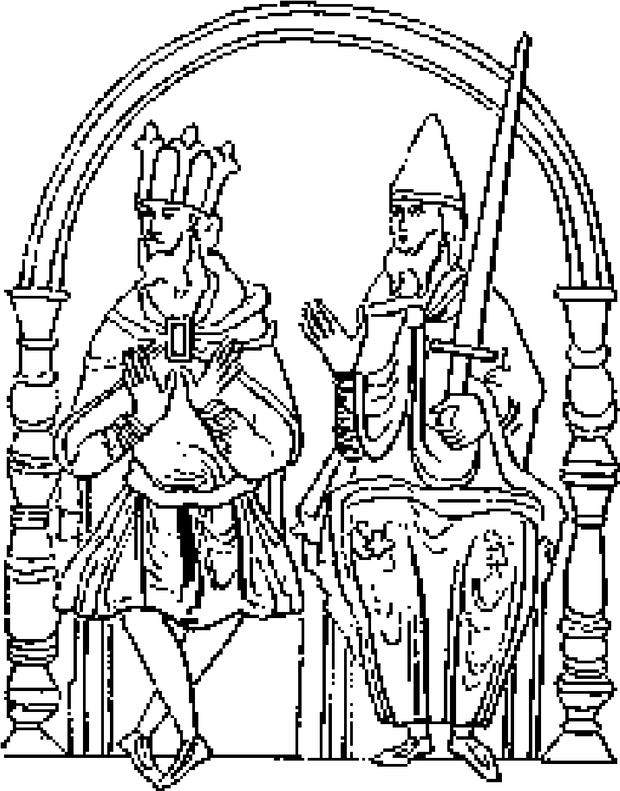

792 - King Aethelred Moll I of Northumbria marries Princess Aelfflaed, daughter of King Offa of Mercia, at Catterick. Unrest in Northumbria tempts the exiled King Osred II back to his kingdom from the Isle of Man. His supporters dessert him and he is killed by King Aethelred's men at Aynburg. He is buried at Tynemouth Priory. King Offa of Mercia arranges coastal defences to fend off Viking attacks. Children :

Aethelred I KING OF NORTHUMBRIA x Elfleda OF MERCIA Married Tuesday 29 September 792

Aethelred I murdered thursday 18 April 796, Corbridge,near HADRIAN's WaLL

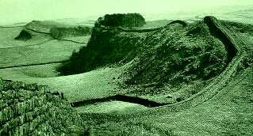

Vervolg

Moll documenten in De Nederlanden van 1190 - 1503

Het oudst bekende document waarin sprake is van een naamdrager Mol(l) in de Noordelijke Nederlanden dateert uit 1186.In dit document wordt Arnoldus Mol met vrouw en kinderen genoemd als erfgenaam met het recht van Dienstmanonder de regering van Hendrik (gehuwd met de erfdochter van de Koning van Sicilie), zoon van Keizer Frederik I Barbarossa (1122-1190,de kruisvaarder en Roomsch Keizer uit het Hohenstaufense huis) en tijdens het voorspoedige bewind van Balduinuis over Utrecht.(Uit "Oorkondenboek van het Sticht Utrecht tot 1301", Dr Muller,1924 pag 458-459)

Een ander oud document is een oorkonde van **Graaf Willem van Henegouwen** aan **Floris Moll** (ZuidHolland) uit 1322

***Wi Willaem Grave van Henegouwen van Holland Maken kont dat wi ghewaren ende ghewen Florijs Moll, vri te sine eyghen vier morghen lands legyhende op Scieven, die Willaem Clays Heerkuns soen waren ende ons anequamen vri bi rechte ende vonnesse der welgheboerne hiemraden van Schieland van morghen melde, dat deze Willaems inghenomen hadde ende anders onghaeld dat opt voerz land liep ende van onsen bailu van Delfland en van Schieland, van wilken ghelde voerse Florus voersz.betaeld heuet dit morghen geld ende dat van onsen weghen dair voren uit geleyd was.***

***In orkonde desen brieve ghegewen in die Haghe des dinxendaghes na Sinte Mardius daghe int Jaer ons heren 1322.***

***Wi Willaem grave ombieden onsen bailu van Scieland ende onsen scoute die aldaer ny syn of hier na wesen zellen dat ghi van al sulken lande als Florys Moll ghecoft heuet daen onse opene brieve of hevet niemant of gheen rechten doet daer of van enighen an sprake of van enighen commer die daer op mocht hebben gheweset of ghemacet was voer deze tyt want het ons toe hewiset es ende anghecmen vri bi rechte ende vonnesse onser welghebernei hiemraden van Scieland.***

***Gheghewen des dinxend. Voer Meydach 1322***

Eveneens een vroeg bericht over naamdragers Mol kan men lezen in:Kroniek en Volksmond van de Achterhoek, blz. 212 :"Hij (= Peter Mol) was een zoon van Gert Mol, die in 1438 van Gosen then Sydenhofe to Mengvelde, priester, en sijne zusters, had gekocht den Zijdenhof to Menckfelde, kerspel Lochem, buurschap Swipe, als een vijfmarksleen.

Peter Mol was gehuwd met Maria, buitenechtelijke dochter van Derk van Keppel heer van Verwolde."Zeer waarschijnlijk wordt hier bedoeld het oorspronkelijke middeleeuwse Kasteel Verwolde dat in 1583 door de Spanjaarden deels werd verwoest.

Stuk 367

Akte van verkoop, verleden voor Johannes Pynappel en Dirk Pels, schepenen van ‘s-Hertogenbosch, door Petrus van Milheze en Marcelius van den Hoevel in hun hoedanigheid van uitvoerders van uiterste wil Geertruid, weduwe Henrik die Lange, aan Petrus Bardeyn van Os van helft van huis “Het Anker” in ‘s- Hertogenbosch op Hinthamereind in richting van klooster Porta Coeli, welke helft Henrik van Stiphout, zoon Henrik, had gekocht van Gerard Moll van Driel en vervolgens had verkocht aan zijn broer Nicolaas, waarna die was gekomen aan diens weduwe Geertruid, die na zijn dood hertrouwde met Henrik die Lange, onder verplichting van daarop grondrenten te vestigen ten behoeve van Leprozenhuis op den Eykendonk, van armenblokken in ‘sHertogenbosch enzovoort, tot fundatie van 2 missen in nieuwe SintAntoniuskapel aldaar, enzovoort, 2 januari 1495 Stuk 413Akte van verkoop, verleden voor Gerardus Kuyst en Philippus Sanders,

schepenen van ‘s-Hertogenbosch, door Lambertus, priester, zoon Petrus Bardeyn van Os, aan zijn broer Johannes Bardeyn, priester van een derde in na te noemen huis met achterhuis, aangezien eerst Henricus van Stiphout Henrikszn helft van huis in ‘s-Hertogenbosch in Hinthamerstraat naast straatje van die straat gaande naar klooster Porta Coeli(“de Hemelpoort”), verkregen had van Gerard Moll van Driel en daarna genoemde Henricus van Stiphout die helft verkocht had aan zijn broer Nicolaus, zijnde voorschreven helft thans een geheel huis met een daarachter gelegen achterhuis en staande het nu tussen voorschreven straatje, enerzijds, en het overige van dat huis, toebehorende eertijds aan Henrik die Lange genaamd in den Anker en zijn vrouw Geertruid, vervolgens aan Coenrard die Cuyper, zoon van Dirk Stevenszn, anderzijds, en aangezien vervolgens Petrus van Milheze en Marcelis van den Hoevel, als executeurs-testamentair van genoemde Reertruid, voorschreven huis met achterhuis, den Anker genaamd, verkocht hebben aan Petrus Bardeyn van Os, 10 maart 1509

Stuk 1397

Testament van Andries Moll Gerardszn en diens echtgenoote Katherina, dochter van Laurentius Gijsbrechtszn, beiden poorters van ‘s-Hertogenbosch, en een nader testament van genoemde Katherina van 7 september 1519, met de inventaris van de gelden door de kerkmeesters der Sint-Janskerk in ‘s-Hertogenbosch in haar nalatenschap ten huize van Roelof van den Broek gevonden, kopie, 14 juni 1503 .

Warnar Moll revised 2019